







**Carol Kirkland**

NAWBO/EXCEL

26677 West 12 Mile Road

Southfield, MI 48034

313-961-4748

YEANAWBODetroit@yahoo.com

Facebook: www.facebook.com/nawboexceldetroit/

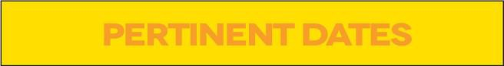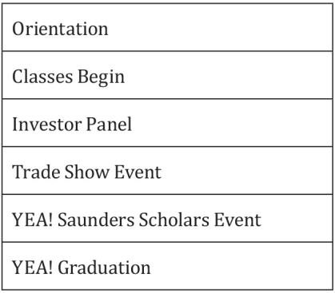

|  |
| --- |
| October 2017 |
| October 2017 |
| March 2018 |
| May 2018 |
| May 2018 |
| May 2018 |





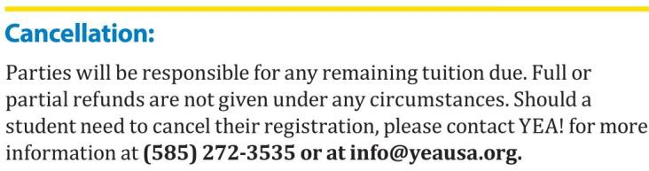

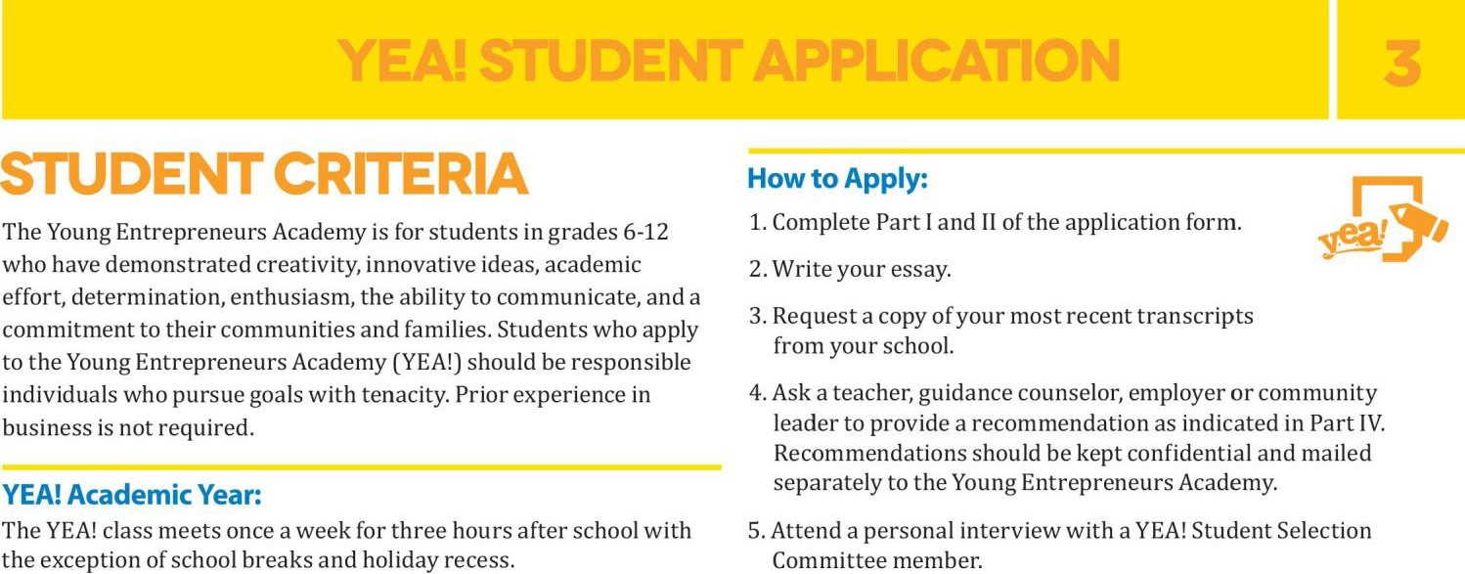

6. Enclose your $25 application fee with your completed application and email or mail to: **Carol Kirkland**

NAWBO/EXCEL

26677 West 12 Mile Rd

Southfield, MI 48034

Academic year begins in October and ends in May

Classes meet every Thursday from 5PM – 8PM



YEANAWBODetroit@yahoo.com

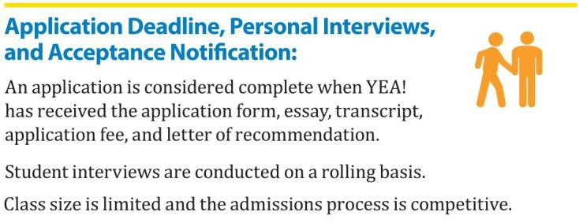

YEA! Academic Year: $395



Deadline for applications for the 2017-18 year is March 31, 2017

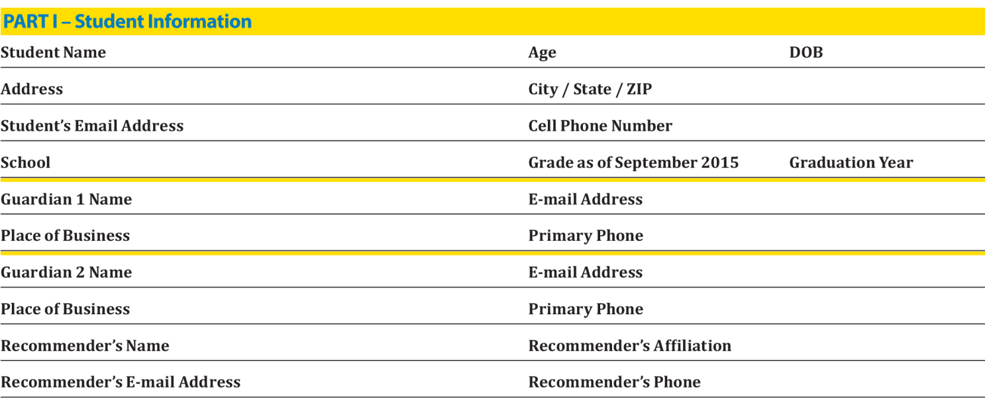

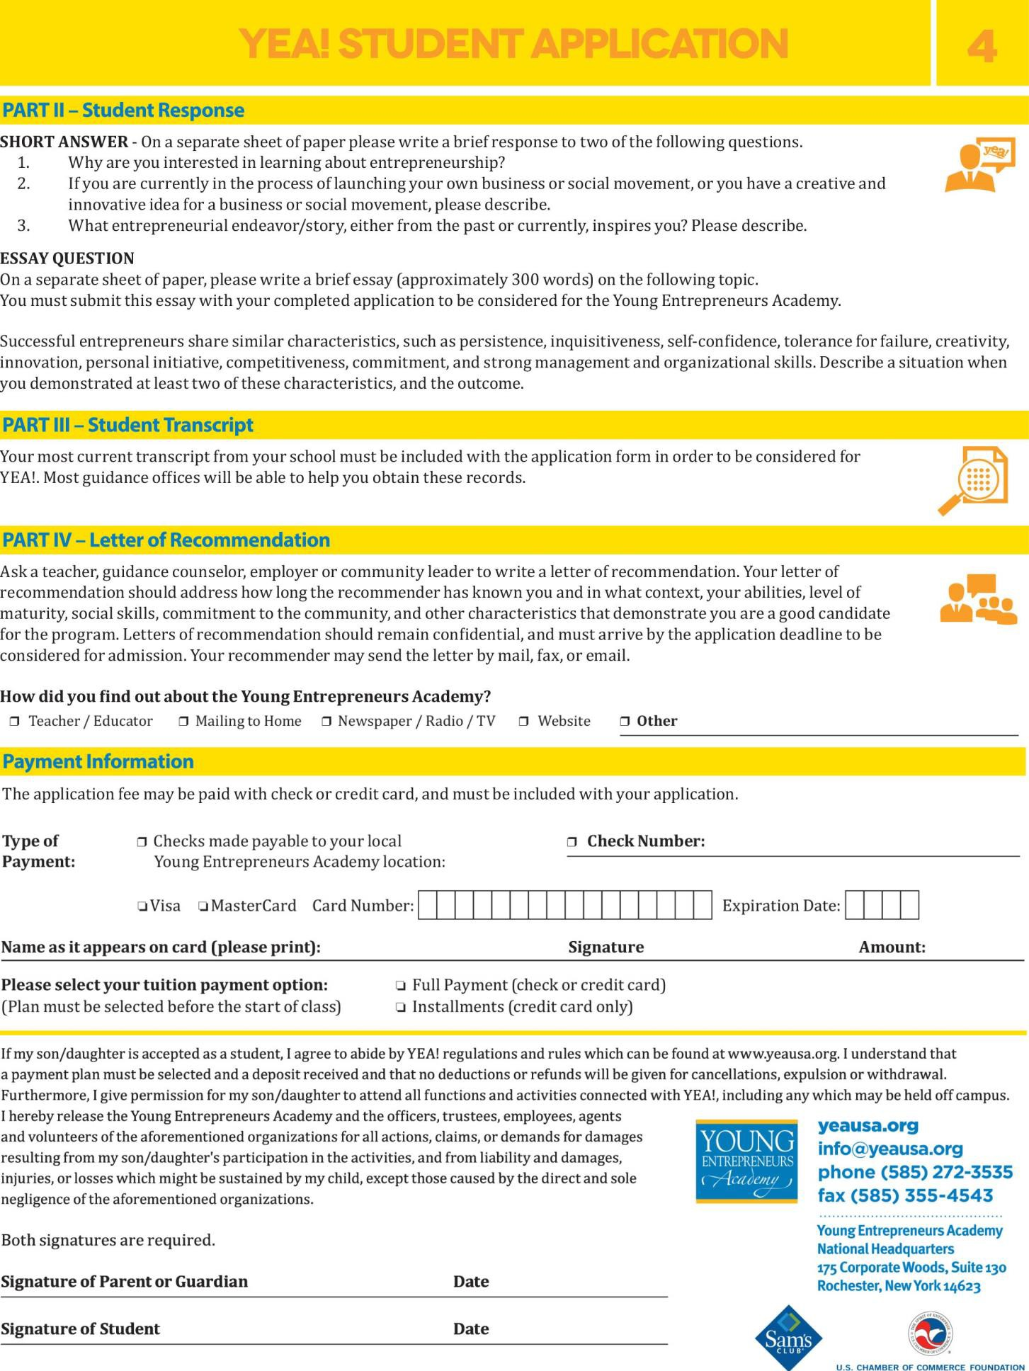

Mail your completed application to: **Carol Kirkland**

NAWBO/EXCEL

26677 West 12 Mile Road

Southfield, MI 48034

**Or** email to YEANAWBODetroit@yahoo.com